Accurant Sample Manager Guide
Version 6.5
Derrick Yu
8-1-24
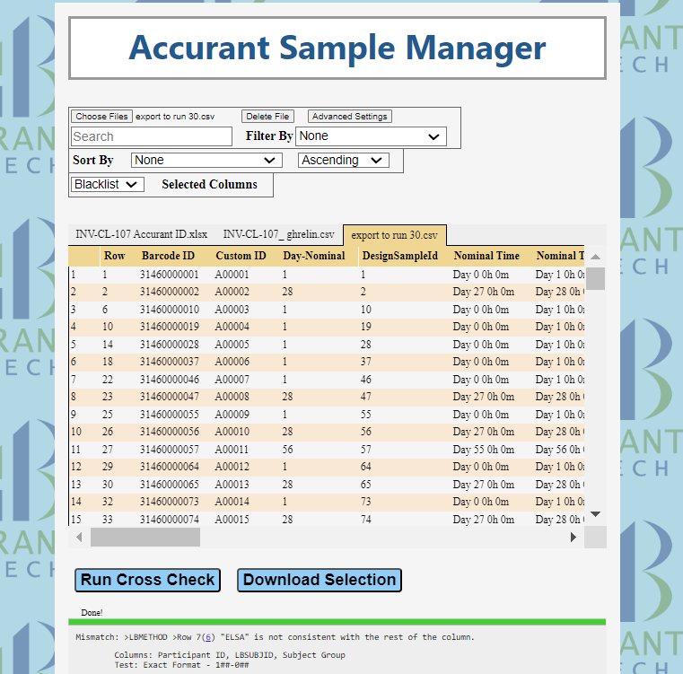
Usage Example

This program can compare two or more spreadsheets with similar data to find inconsistencies between the spreadsheets.

Here is an example of two files that could be compared for errors.
Spreadsheet 1:
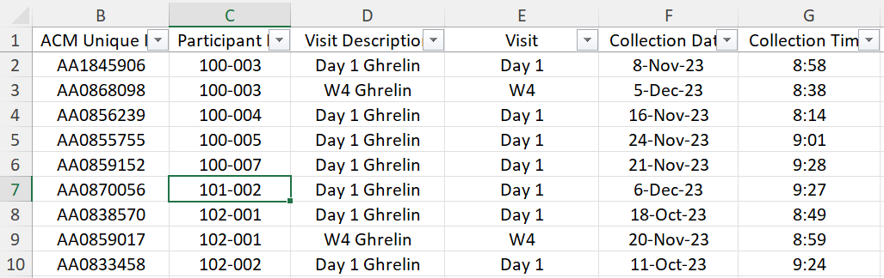
Spreadsheet 2:
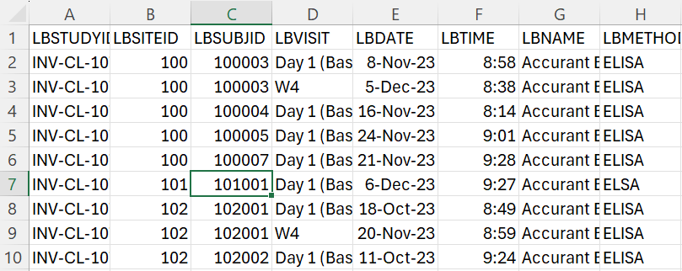

First, the files are uploaded to the website.
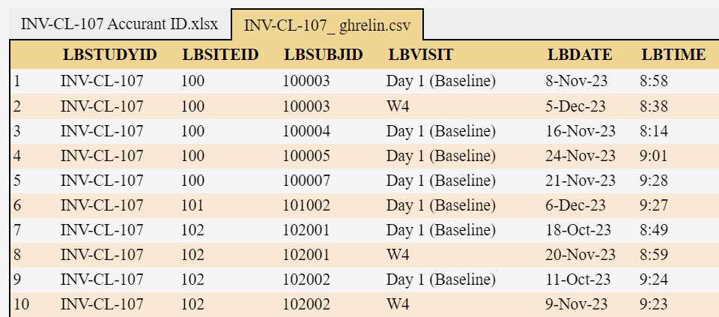

When the button “Run Cross Check” is pressed, the program will run an algorithm to automatically match and cross check columns from the uploaded spreadsheets.
At this point, the program will produce an output below the spreadsheet.
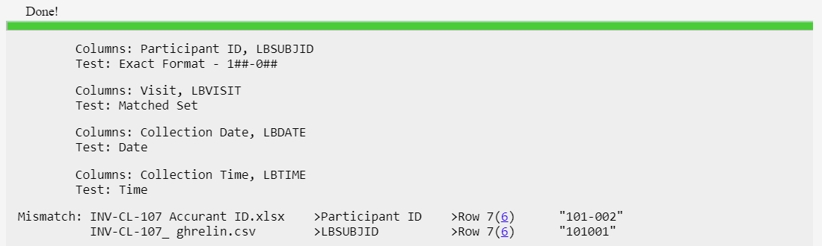

The first four outputs (highlighted) report what columns the algorithm matched together, and what test it used to find inconsistencies.
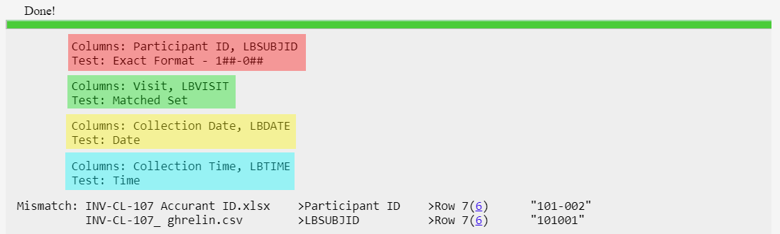

In terms of the excel sheet, the following columns were matched.
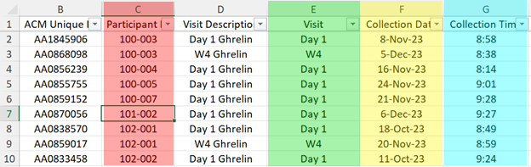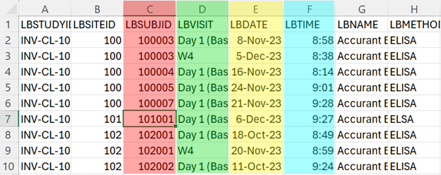
The last output (highlighted) reports a mismatch that was found between the spreadsheets.
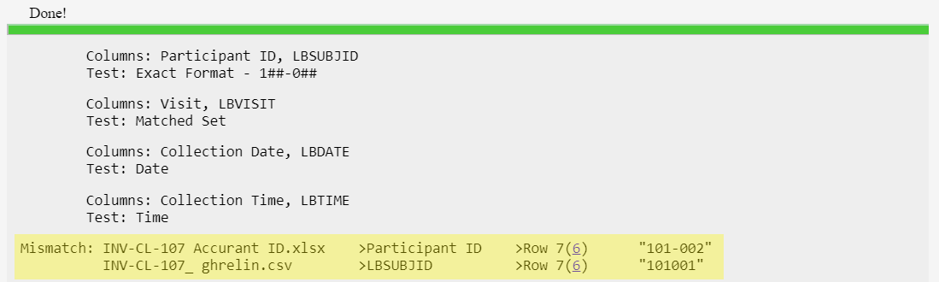
Mismatches are reported with the following format:
Mismatch: File1 Name >Column1 Name >Row in file (relative row) “Cell1 Value”
File2 Name >Column2 Name >Row in file (relative row) “Cell2 Value”

Notice how LBSUBJID row 7 and Participant ID row 7 are not consistent.
Using the output, you can then edit the cells in the corresponding excel files and resolve the mismatch.
In addition to detecting mismatches, the program will also detect format errors (if applicable) and value inconsistencies within columns (if applicable).

How To Use

This application is a website that can only be accessed on company computers in our Cranbury, NJ site.
To access the website, click on the link below. Alternatively, type in the link into your browser.
sonic.qasper.bio

Step 1. Remove any extraneous data
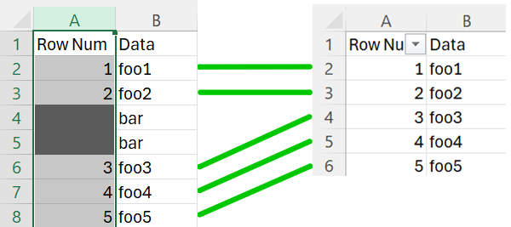
In the example above, the rows with the gray boxes in the left spreadsheet must be deleted to match the right spreadsheet.

Step 1-1. Make a copy of the excel file with extra rows.
We will delete the extra rows, so we need to perform this on a copy of the original data.

Step 1-2. Filter rows by unwanted data.
In excel, select the column of data you want to filter by. In this case we will filter by the “row num” column because we want to delete rows with the gray boxes.
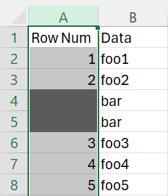
Navigate the data menu, then click on filter.
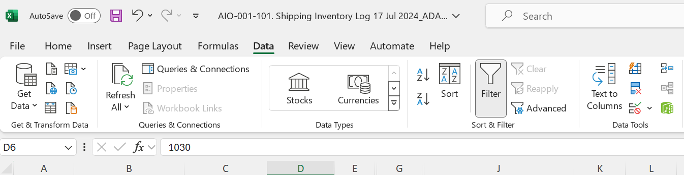
Now you should see a small box with an arrow next to the header of the column.
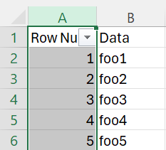

Clicking on the arrow will open the sort/filter menu.
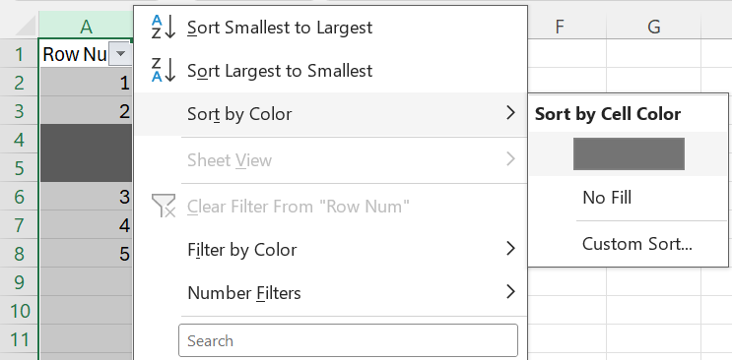
In this case, we will only filter by color. However, you can also filter by cell values, or apply multiple filters using other columns.
After clicking on the dark gray color, we will only see rows with the dark gray boxes in the “row num” column.
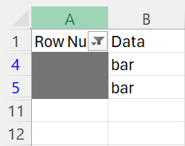
Now, select and delete these rows.
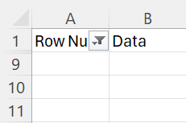

Step 1-3. Remove the filter.
Click on the small box next to the header again, and then click on the
Clear Filter option.
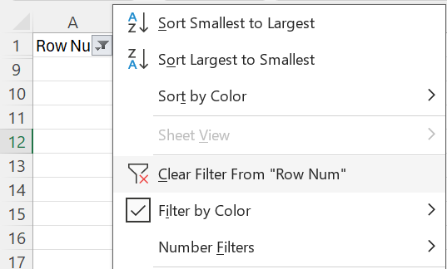

All the extra rows have been removed.
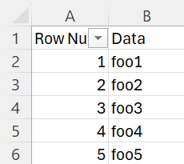

Step 2. Sort rows so that they match each other.
At this point all extra rows have been removed. However, the rows still may not be in order.
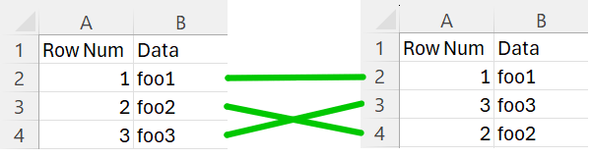
If you have an ID column in both files, you can sort both files by that column through the sort/filter menu.
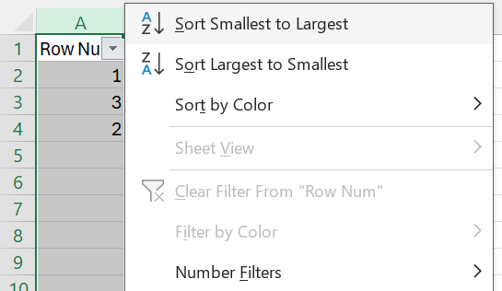

If you do not have an ID column in both files, you may need to perform a layered sort.
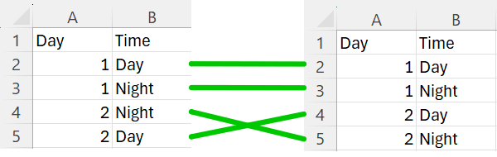
In this case, the rows are correct, but they are out of order, and there is no ID column to sort by. However, the row can be Identified using the “Day” column and the “Time” column.
To perform a layered sort, select all data by clicking the triangle in the corner. Then navigate to the data menu and click on Sort.

The Sort menu should open

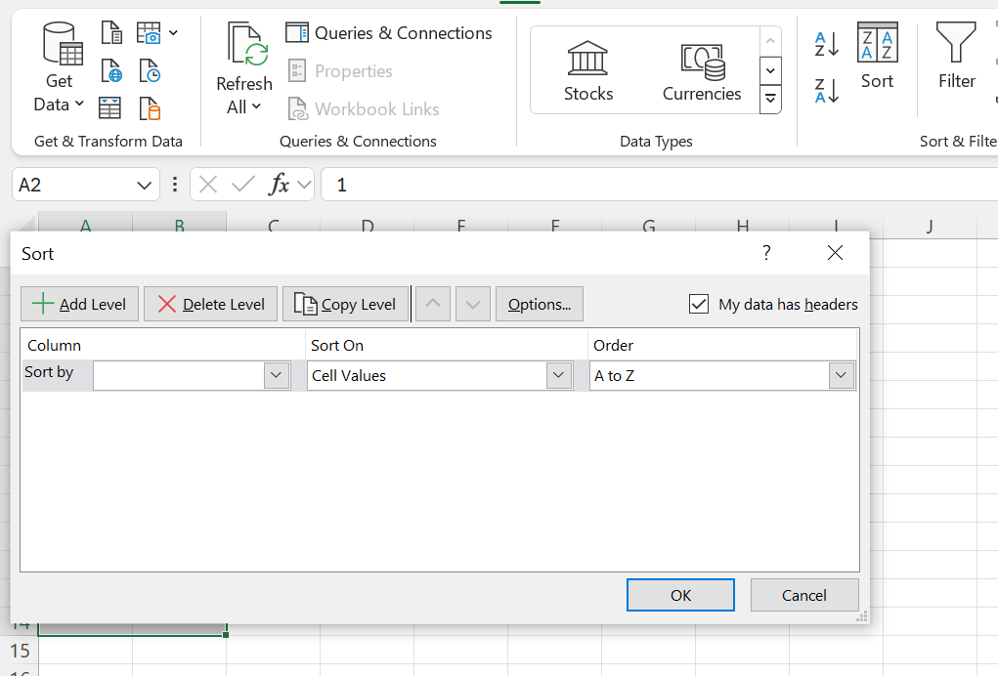

We will sort by “Day” first.
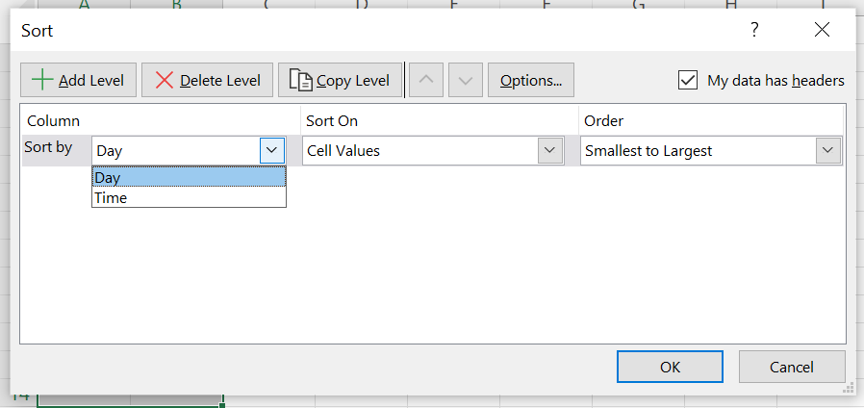
Then click on add level
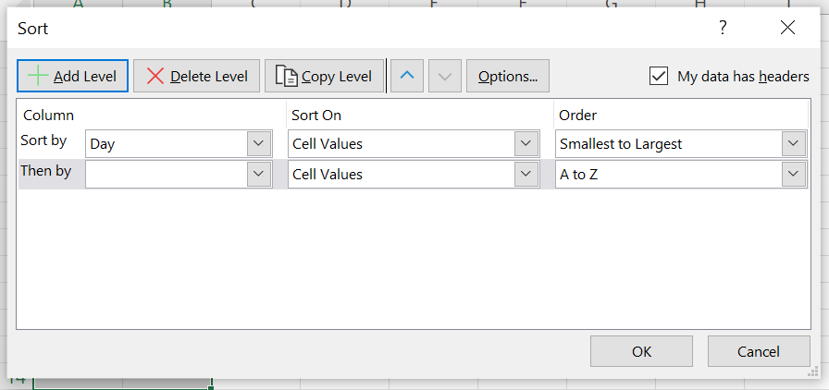
Then sort by “Time”
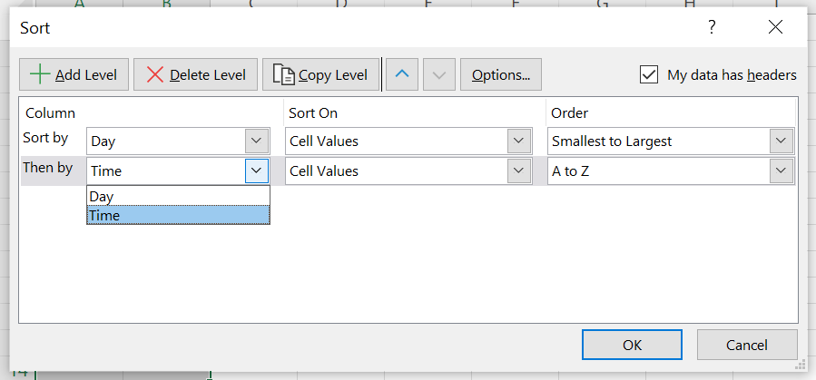

Now we have matching rows.
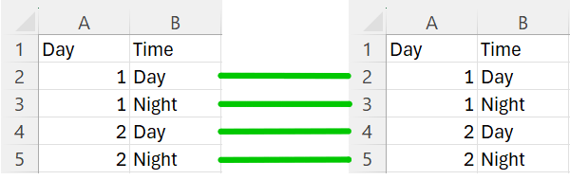
Repeat this layered sort on your other files.

Double check for misalignment or unexpected rows.
Export headers and export trailers will be automatically removed when the file is uploaded. However, if this does not work properly, you will need to manually remove them.

Step 3. Upload your files

Click on “Choose Files” in the top right corner of the website and upload your files. Only .xlsx and .csv files are accepted.
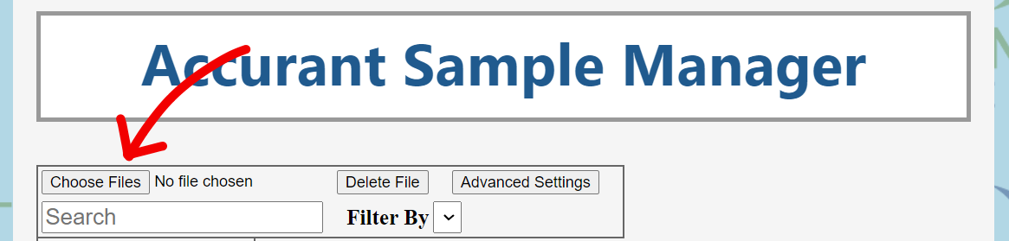

Your Spreadsheets should open on the website.
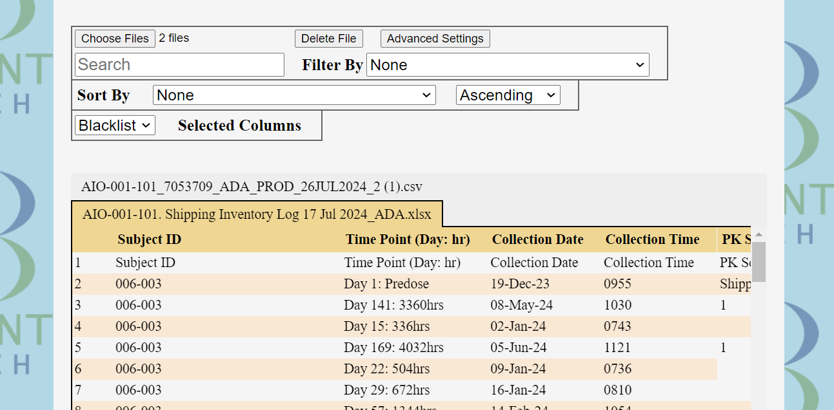

Click on “Run Cross Check”
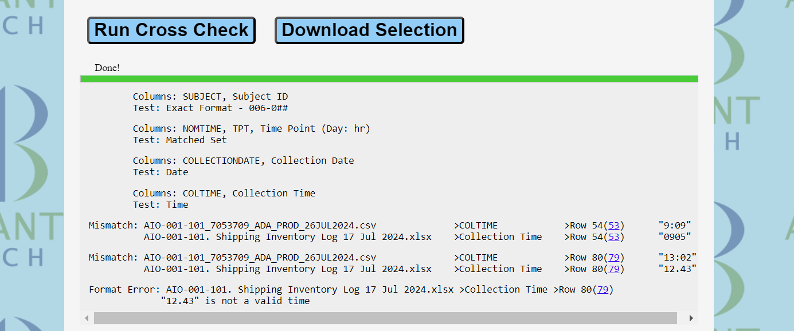
Results will be printed in an output at the bottom of the page. Use these results to resolve errors in your files!

This output indicates which columns were matched and checked, and which test was used to cross check them.
Columns: Column1 Name, Column2 Name, ...
Test: Test Type
This output indicates a mismatch between two cells.
Mismatch: File1 Name >Column1 Name >Row in file (relative row) “Cell1 Value”
File2 Name >Column2 Name >Row in file (relative row) “Cell2 Value”
This output indicates a format error in a single cell.
Format Error: File Name >Column Name >Row in file (relative row)
“Cell1 Value” is not a valid format
This output indicates a value inconsistency in a single cell.
Inconsistency: File Name >Column Name >Row in file (relative row) “Cell1 Value”

Mismatch link:
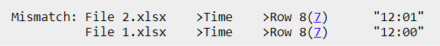
Clicking on the blue link in parentheses will take you to the cell where the mismatch happened. The number in the link is the relative row number. This is the common row number given to rows in the website. It is also the number you see before the first column in the website. It does not correspond to the same row in the excel file. The row in the excel file is the number before the parentheses.

Selecting outputs:
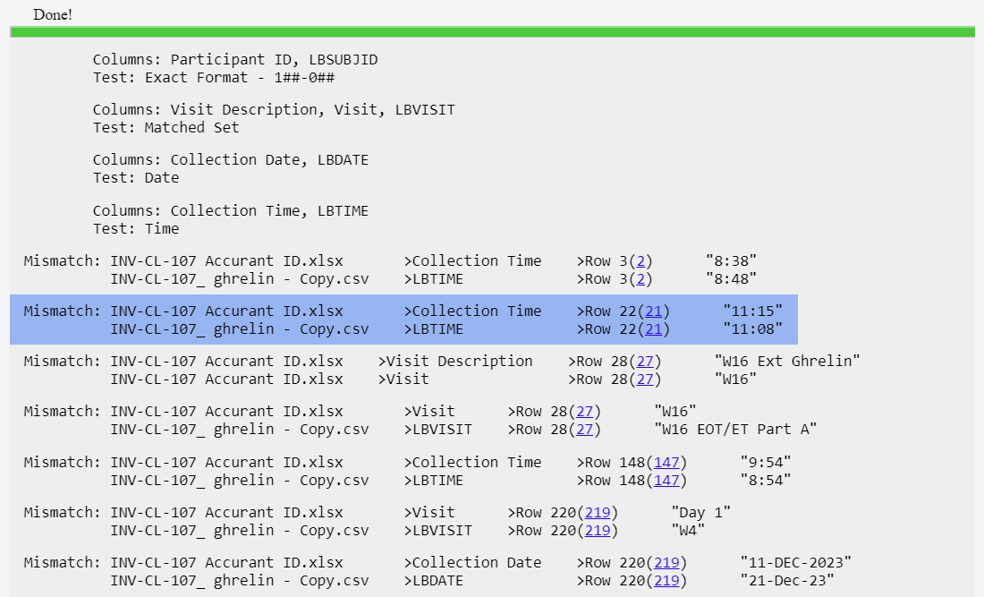
Outputs can be messy with many results that you do not need. You can select important outputs by clicking on them, which will highlight them. Click on the output again to deselect it.

Troubleshooting

Before referring to the troubleshooting section, please ensure that you have followed all steps in the “How to Use” section.

Issues:
Nothing is displayed in the output.
The columns I need to cross check are not getting matched.

Try increasing the error tolerance in advanced settings. The smaller or messier the spreadsheet, the larger the error tolerance may have to be.
500-2000 rows recommended error tolerance 0.02
100-500 rows recommended error tolerance 0.05
30-100 rows recommended error tolerance 0.1
OR
Check how the spreadsheet is displayed on the website. Check for strange rows at the beginning of the table. Scroll down to the bottom of table and check for untruncated export trailers and ghost rows.
If you encounter any strange rows, delete them in excel, re-import the file, and run the cross check again.

Issues:
Too much is displayed in the output.
Unrelated columns are being matched.
Columns are being compared using the wrong test.

Try decreasing the error tolerance, turning off “Check Uniform Columns”, or turning off “Show Null Values” in advanced settings.
OR
Blacklist columns that do not need to be checked by clicking on the column header.
OR
If you want to check specific columns, choose whitelist columns and select only the columns you want matched. You may want to increase the error tolerance when whitelisting columns.

Issue:
Row Shift Warning
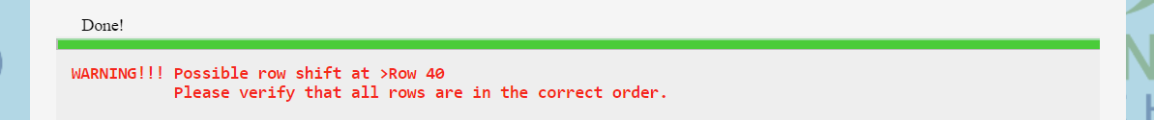
The program has detected shifted rows, either inserted, missing, or out of order, at the relative row number indicated. Scroll to the relative row in the website and inspect each file for shifted rows. Fix this in excel, re-import the file, and run the cross check again.
Additional Information

Website Index
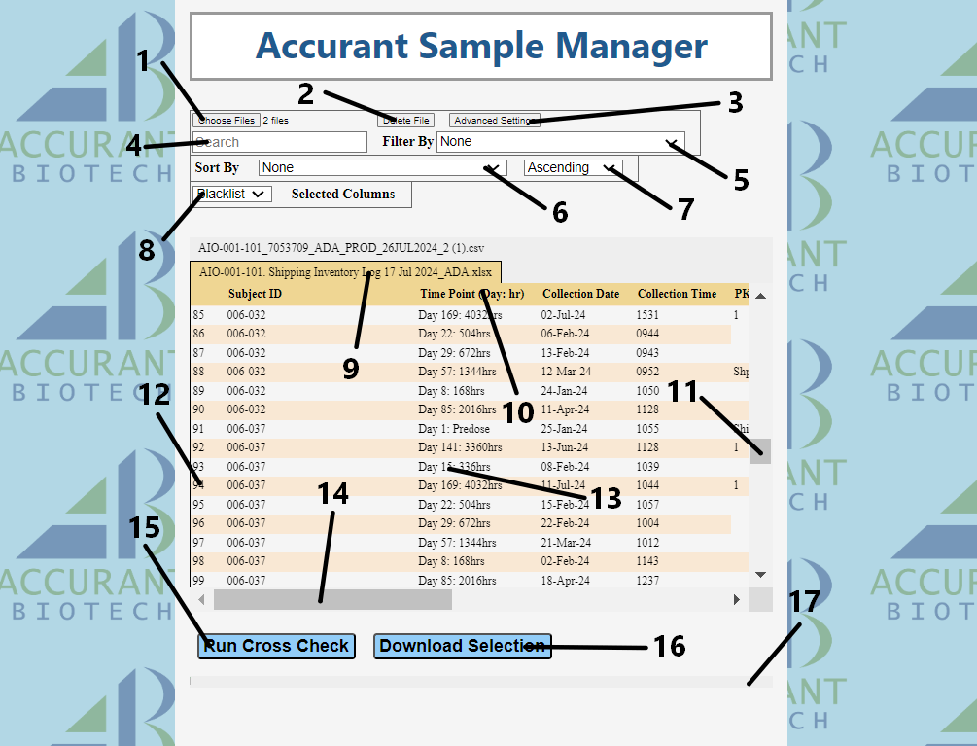

- Choose File Button – Select one or more files of type .xlsx or .csv
- Delete File Button – Delete the file that is currently displayed.
- Advanced Settings Button - Opens the advanced settings menu.
- Search Bar – Search for a cell value in the current file.
- Filter Selector – select the column to filter search results by.
- Sort By Selector – select the column to sort search results by.
- Sort Order Selector – sort in ascending or descending order.
- Blacklist/Whitelist selector – choose whether selected columns are blacklisted or whitelisted by the cross-checking algorithm.
- File Navigation bar – Click on a file name to display that file in the table below.
- Column Header – click on a column header to select it.
- Vertical scroll bar
- Relative row number – a common row number given to matching rows in the website.
- Table data – Current file data is displayed here.
- Horizontal Scroll Bar
- Run Cross Check Button – Click to begin cross checking all uploaded files.
- Download Current Selection as an excel spreadsheet.
- Output List – Cross check results are displayed here.

Advanced Settings Index
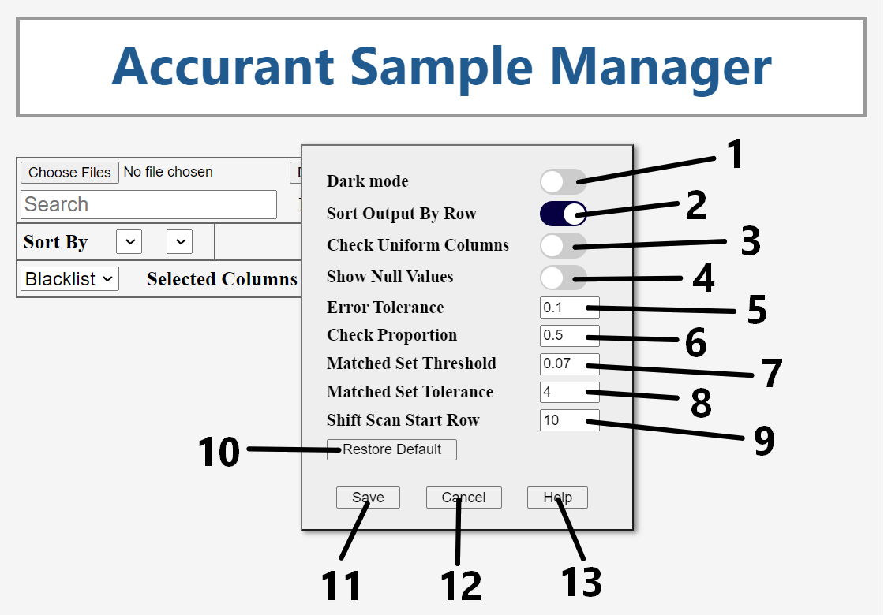

- Dark Mode Toggle – Changes website styling to dark mode. Off by default
- Sort Output by Row Toggle – If on, output is displayed in row order. If off, output is displayed in column order. On by default.
- Check Uniform Columns Toggle – If on, display inconsistency errors. On by default.
- Show Null Values Toggle – If on, display mismatches and format errors with blank cells. On by default.
- Error Tolerance – the proportion of differences the program will tolerate when matching columns. Higher values will make the program match more columns. Default value 0.02.
- Check Proportion – The proportion of cells the program will sample from columns in the matching process. Default value 0.5.
- Matched Set Threshold – The maximum proportion of unique values in a column until it is categorized as the “Multiple Choice” data type. Multiple Choice data types are compared using the “Matched Set” test.
- Matched Set Tolerance – The equivalent of Error Tolerance for matched set cross checking. The lower this number is, the more matched set mismatches will be thrown.
- Shift Scan Start row – When checking for row shifts, the algorithm will match columns using only rows 0 until the shift scan start row, after which, the program will be able to detect row shifts. If a row shift occurs before the shift scan start row, the program will not be able to detect it.
- Restore Default Button – Restores all default settings when clicked.
- Help Button – opens a help menu with information about the program, tips, and troubleshooting help.
- Cancel button – Closes the settings menu and cancels any changes to the settings.
- Save button – Closes the settings menu and saves and changes to the settings.

